* **What is a software ?**

Software is a program or set of programs containing instructions that provide desired functionality. Engineering is the process of designing and building something that serves a particular purpose and finds a cost-effective solution to problems.

* What is software engineering ?

Software Engineering is the process of designing, developing, testing, and maintaining software. It is a systematic and disciplined approach to software development that aims to create high-quality, reliable, and maintainable software.

* Explain types of software

1. **Application software -** The most common type of software, application software is a computer software package that performs a specific function for a user, or in some cases, for another application. An application can be self-contained, or it can be a group of programs that run the application for the user.
2. **System software -** These software programs are designed to run a computer's application programs and hardware. System software coordinates the activities and functions of the hardware and software. In addition, it controls the operations of the computer hardware and provides an environment or platform for all the other types of software to work in.
3. **Driver software -**Also known as device drivers, this software is often considered a type of system software. Device drivers control the devices and peripherals connected to a computer, enabling them to perform their specific tasks. Every device that is connected to a computer needs at least one device driver to function.
4. **Middleware -**The term middleware describes software that mediates between application and system software or between two different kinds of application software.
5. **Programming software -** Computer programmers use programming software to write code. Programming software and programming tools enable developers to develop, write, test and debug other software programs.

* **What is SLDC ?**

The software development lifecycle (SDLC) is the cost-effective and time-efficient process that development teams use to design and build high-quality software. The goal of SDLC is to minimize project risks through forward planning so that software meets customer expectations during production and beyond. This methodology outlines a series of steps that divide the software development process into tasks you can assign, complete, and measure.

* **Explain each phase of SLDC**
* **Plan**

The planning phase typically includes tasks like cost-benefit analysis, scheduling, resource estimation, and allocation. The development team collects requirements from several stakeholders such as customers, internal and external experts, and managers to create a software requirement specification document.

The document sets expectations and defines common goals that aid in project planning. The team estimates costs, creates a schedule, and has a detailed plan to achieve their goals.

* **Design**

In the design phase, software engineers analyze requirements and identify the best solutions to create the software. For example, they may consider integrating pre-existing modules, make technology choices, and identify development tools. They will look at how to best integrate the new software into any existing IT infrastructure the organization may have.

* **Implement**

In the implementation phase, the development team codes the product. They analyze the requirements to identify smaller coding tasks they can do daily to achieve the final result.

* **Test**

The development team combines automation and manual testing to check the software for bugs. Quality analysis includes testing the software for errors and checking if it meets customer requirements. Because many teams immediately test the code they write, the testing phase often runs parallel to the development phase.

* **Deploy**

When teams develop software, they code and test on a different copy of the software than the one that the users have access to. The software that customers use is called *production*, while other copies are said to be in the *build environment*, or testing environment.

Having separate build and production environments ensures that customers can continue to use the software even while it is being changed or upgraded. The deployment phase includes several tasks to move the latest build copy to the production environment, such as packaging, environment configuration, and installation.

* **Maintain**

In the maintenance phase, among other tasks, the team fixes bugs, resolves customer issues, and manages software changes. In addition, the team monitors overall system performance, security, and user experience to identify new ways to improve the existing software.

* **What is DFD ?**

DFD is the abbreviation for Data Flow Diagram. The flow of data of a system or a process is represented by DFD. It also gives insight into the inputs and outputs of each entity and the process itself. DFD does not have control flow and no loops or decision rules are present. Specific operations depending on the type of data can be explained by a flowchart. It is a graphical tool, useful for communicating with users ,managers and other personnel. it is useful for analyzing existing as well as proposed system.

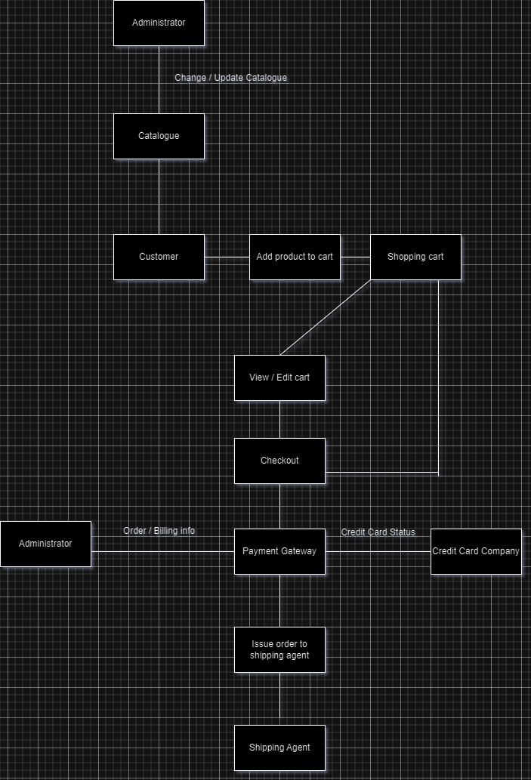

* **What is Flow chart ?**

A flowchart is a diagram that depicts a process, system or computer algorithm. They are widely used in multiple fields to document, study, plan, improve and communicate often complex processes in clear, easy-to-understand diagrams.

* **Flow chart to make addition of two numbers**